Regression Models on Synthetic Dataset - Results

Synthetic Dataset creation:

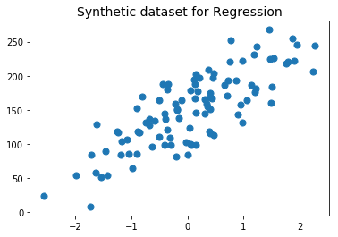

Part-1: KNN Regression:

5NN regression results:

The predicted values on the test set:

[ 231.70974697 148.35572605 150.58852659 ..., 128.01545355 123.14247619

141.90634426]

R-squared value of test data: 0.425

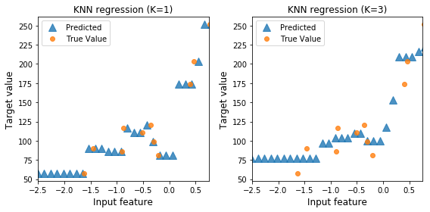

Part-2: Linear Regression Model Results:

Linear Model Slope (m): [ 45.70870465]

Linear Model Intercept (b): 148.446

R-squared score (training): 0.679

R-squared score (test): 0.492

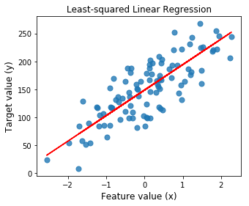

Part-3 Ridge Regression Model Results:

Ridge Regression without feature scaling:

Ridge Regression Linear Model Intercept: 148.486

Ridge Regression Linear Model Slope:[ 36.26506226]

R-squared score (training): 0.650

R-squared score (test): 0.545

Number of non-zero features: 1

Ridge Regression after feature scaling:

Ridge Regression Linear Model Intercept: 132.077

Ridge Regression Linear Model Slope:[ 31.23837752]

R-squared score (training): 0.525

R-squared score (test): 0.430

Number of non-zero features: 1

Ridge regression: Effect of varying alpha regularization parameter:

Alpha = 0.00

No. of abs(coeff) > 1.0: 1, R-squared training: 0.68, r-squared test: 0.49

Alpha = 1.00

No. of abs(coeff) > 1.0: 1, R-squared training: 0.64, r-squared test: 0.55

Alpha = 10.00

No. of abs(coeff) > 1.0: 1, R-squared training: 0.30, r-squared test: 0.29

Alpha = 20.00

No. of abs(coeff) > 1.0: 1, R-squared training: 0.18, r-squared test: 0.17

Alpha = 50.00

No. of abs(coeff) > 1.0: 1, R-squared training: 0.08, r-squared test: 0.07

Alpha = 100.00

No. of abs(coeff) > 1.0: 1, R-squared training: 0.04, r-squared test: 0.03

Alpha = 1000.00

No. of abs(coeff) > 1.0: 0, R-squared training: 0.00, r-squared test: -0.01

Part-4 Lasso Regression Model Results:

Lasso Regression Linear Model Intercept: 55.839

Lasso Regression Linear Slope:[ 175.01578083]

Non-zero features: 1

R-squared score (training): 0.650

R-squared score (test): 0.545

Lasso Regression : Effect of varying alpha regularization parameter:

Alpha = 0.50

Features kept: 1, r-squared training: 0.68, R-squared test: 0.51

Alpha = 1.00

Features kept: 1, r-squared training: 0.67, R-squared test: 0.53

Alpha = 2.00

Features kept: 1, r-squared training: 0.65, R-squared test: 0.55

Alpha = 3.00

Features kept: 1, r-squared training: 0.61, R-squared test: 0.54

Alpha = 5.00

Features kept: 1, r-squared training: 0.50, R-squared test: 0.47

Alpha = 10.00

Features kept: 0, r-squared training: 0.00, R-squared test: -0.02

Alpha = 20.00

Features kept: 0, r-squared training: 0.00, R-squared test: -0.02

Alpha = 50.00

Features kept: 0, r-squared training: 0.00, R-squared test: -0.02